Lab 4 - Microservices Decomposition & Communication
Contents
1. Cover Page 1
2. Abstract / Summary 1
3. Lab-Specific Section: Microservices Decomposition & Communication 2
3.1 Decomposition by Business Capability 2
3.2 Service Contracts (API Endpoints) 2
3.3 Communication Strategy 3
4. C4 Model – Level 1 (System Context) 3
5. Conclusion & Reflection 4

Cover Page
• Title: Microservices Decomposition & Communication
• Course Info: Software Architecture
• Student Details: [NGUYEN QUE BAC], [23010574]; [HOANG TUAN KIET], [23010517]; [DO BAO LONG], [23010561]
• Date: January 25, 2026

2. Abstract / Summary
Lab 4 centers on analyzing how a monolithic application can be decomposed into microservices, and although our Book Ticket project is currently implemented as a Monolith with a layered architecture, this lab serves as a design exercise to envision its evolution into a microservices architecture that supports scalability and fault isolation. In this lab, we identified the main business domains—User Management, Movie Management, Showtime Management, Booking, Payment, and Notification—and mapped each to an independent microservice with its own data ownership. We documented service contracts by defining API endpoints for key services, such as the Booking Service with create, cancel, and retrieve operations, and the Movie Service with listing and filtering functions. We also designed a communication strategy, using synchronous HTTP for critical operations like seat availability checks and payment confirmation, and asynchronous messaging for non-critical tasks such as sending confirmation emails. Finally, we created a C4 Model (Level 1 – System Context) diagram to illustrate the Book Ticket system boundary, external actors including customers and administrators, and external systems such as the Payment Gateway and Email Provider, along with their communication flows.

3. Lab-Specific Section: Microservices Decomposition & Communication

3.1 Decomposition by Business Capability
We identified the main business domains of the Book Ticket system and mapped them into independent microservices. Each service owns its own data and operates autonomously.
Business Capability | Proposed Microservice | Data Owned (Entities)
User Management | User Service | User profiles, authentication credentials, passwords
Movie Management | Movie Service | Movie details, genres, descriptions, posters
Showtime Management | Showtime Service | Showtimes, seat maps, auditorium info
Booking | Booking Service | Bookings, tickets, booking status
Payment | Payment Service | Transactions, payment status, receipts

3.2 Service Contracts (API Endpoints)
We defined the public API for the Booking Service as an example. Other services interact with it through these endpoints rather than accessing its database directly.
Booking Service API:
- POST /api/bookings → Create a new booking. Request: { "showtimeId": 123, "seat": "A5", "userId": 45 } Response: { "bookingId": 999, "status": "confirmed" }
- GET /api/bookings/{id} → Retrieve booking details. Response: { "bookingId": 999, "movie": "Avengers", "seat": "A5", "status": "confirmed" }
- DELETE /api/bookings/{id} → Cancel a booking. Response: { "bookingId": 999, "status": "cancelled" }

3.3 Communication Strategy
We analyzed which interactions require synchronous communication and which can be asynchronous.
Interaction | Service Flow | Communication Type | Rationale
Seat Availability Check | Booking → Showtime | Synchronous (HTTP) | Must verify seat instantly before booking.
Payment Confirmation | Booking → Payment | Synchronous (HTTP) | Booking cannot proceed without payment confirmation.

4. C4 Model – Level 1 (System Context)
At the system context level, the Book Ticket platform interacts with users and external systems.
- System: [System] Book Ticket Platform
- Actors:
  - Web Customer → browses movies, books tickets.
  - Administrator → manages movies, showtimes.
- External Systems:
  - Payment Gateway → processes payments (synchronous HTTP).
  - Email/SMS Provider (gửi thông báo).
- Communication Flows:
  - Customer → Book Ticket (HTTP requests).
  - Book Ticket → Payment Gateway (HTTP synchronous).
  - Admin ↔ Book Ticket: HTTP (Manage movies, showtimes, users).
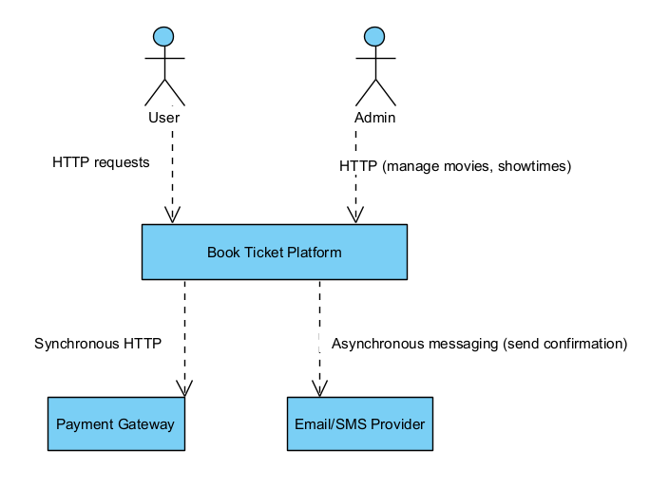
System Context Diagram

5. Conclusion & Reflection
In Lab 4, we explored how the Book Ticket system, currently implemented as a monolith, could be decomposed into microservices. Through this exercise, we identified key business capabilities such as User, Movie, Showtime, Booking, Payment, and Notification, and mapped them into independent services with clear data ownership. We also defined service contracts and analyzed communication strategies, distinguishing between synchronous and asynchronous interactions. Although our project remains monolithic, this lab provided valuable insights into scalability, fault isolation, and the importance of well-defined service boundaries, preparing us for potential future migration to a microservices architecture.

